SIMATS ENGINEERING

ASSESSMENT TOOL 1 : Concept Mapping

COURSE NAME: | Cloud Computing and  Big Data Analytics | COURSE CODE: | CSA15

COURSE OUTCOME COVERED
CO1: Apply cloud computing technologies including hardware-software evolution, virtualization, web services, and service models to develop cloud-based solutions. (BL2)

Dave's Taxonomy: Imitation (Level 1)  Question Count: 4 | Total Marks: 50

Code of Conduct
I K. VSLC LOHITH (192525319)certify that this submission is my original work and that I have adhered to the guidelines specified for this assessment.
I understand that any violation of academic integrity rules will result in disciplinary action. Signature of the student: K.Lohith
Assessment Tasks Concept Mapping Tasks
Create concept maps for the following tasks. Each map must show key nodes, link labels, and a logical hierarchy.
- Concept Map 1: Cloud Computing Fundamentals. Include definition, characteristics, benefits, and limitations.
- Concept Map 2: Evolution of Cloud Computing. Connect hardware evolution, internet software evolution, distributed systems, and service delivery.
- Concept Map 3: Service Models. Map IaaS, PaaS, SaaS, and XaaS with provider responsibilities and user responsibilities.
- Concept Map 4: Virtualization and Web Services as Enablers of Cloud. Show how these two concepts support cloud deployment and scalability.
Expected concept nodes:
  - Elasticity, scalability, resource pooling, on-demand access, measured service
  - Virtual machine, hypervisor, abstraction, API, SOAP, REST, provider, consumer
  - Infrastructure layer, platform layer, application layer, shared responsibility

Concept Mapping Rubric

Criteria | Weightage | Level 4 - Exemplary | Level 3 - Proficient | Level 2 -  Developing | Level 1 -  Beginning
Concept  Identification | 25% | All major concepts are  accurately identified | Most concepts are  identified correctly | Limited concepts  are identified | Essential concepts  are missing
Relationship Mapping | 25% | Links between concepts are accurate and  meaningful | Most links are correct | Some links are weak or unclear | Relationships are mostly incorrect
Hierarchy and Organization | 20% | Excellent structure with clear hierarchy | Mostly organized with minor issues | Basic structure with weak  hierarchy | No logical organization
Technical  Relevance | 20% | Map strongly reflects  cloud course content | Mostly aligned to  topic | Partially aligned  to topic | Weak alignment  to topic
Visual Clarity | 10% | Neat, readable, and easy  to interpret | Generally readable | Somewhat  cluttered | Poorly presented

Total Marks:

Permitted Tools :

draw.io / diagrams.net, Lucidchart, MindMeister, Miro, Canva, PowerPoint, Google Drawings, or equivalent diagramming tool
Procedure for Preparing the Digital Concept Map
- Use the following procedure to prepare the diagram and upload evidence.
- Students who already know another diagramming tool may use it, but the exported evidence and source file must still be submitted.
- Open https://app.diagrams.net/ or the desktop version of draw.io / diagrams.net.
- Choose Device, Google Drive, or OneDrive as the save location according to availability.
- Create a blank diagram and name the file as
CSA15_CO1_AT1_RegisterNumber_Concept_Map.drawio.
- Place the concept map title at the center or as a clearly visible anchor node.
- Add major cloud nodes: cloud definition, cloud evolution, cloud architecture, service models, deployment models, virtualization, web services, SOAP, REST, APIs, elasticity, scalability,
resource pooling, measured service, and emerging paradigms.
- Connect nodes with labeled arrows such as uses, depends on, enables, scales through, communicates through, belongs to, supports, provides, consumes, or controls.
- Use colors meaningfully: one color for service models, one for cloud characteristics, one for API/web-service concepts, and one for concept map title-specific elements.
- Export the final diagram as PNG or PDF. Keep the editable .drawio source file also.
- Paste the exported diagram image or screenshot in this DOCX under Task 1.
- Upload the DOCX, exported PNG/PDF, and .drawio file to Google Classroom.

Task 1: Concept Map
Create a concept map in draw.io, Lucidchart, Miro, Figma, or any suitable diagramming tool. The map must connect cloud ecosystem, cloud actors, service models, deployment models, virtualization, web services, REST/SOAP APIs, scalability, elasticity, and the student's Project.

Task 2A: Service Model Responsibility Matrix
Prepare a technical matrix that compares SaaS, PaaS, IaaS, FaaS/serverless, database-as-a-service, storage-as-a-service, identity-as-a-service, and monitoring/logging services. For each selected service category, explain what is managed by the cloud provider, what is managed by the student application team, and why that split fits the Project.

Task 2B: Cloud Service Decision Matrix
Map Project modules to cloud services. Include authentication, frontend hosting, backend/API layer, database, object storage, analytics/logging, notification, AI/Python module, security, CI/CD, backup, and monitoring. Students should justify the most relevant service choices instead of forcing every possible cloud service into the design.

Task 3: API Flow, Elasticity, and Scalability Design
Draw a professional cloud-flow diagram for the Project modules. The diagram must show user app or web app, API gateway/backend service, authentication, compute layer, database, object storage,

analytics/logging, monitoring, security boundaries, and scaling points. Students may replicate the given visual pattern, but all components and labels must be customized to their own architecture.

Task 4: Technical Justification
Write a concise justification explaining how the diagram and matrices prove CO1. The justification must discuss service model selection, API role, elasticity, scalability, virtualization or managed compute choice, and cloud responsibility boundaries.

1. Evaluate the effectiveness of your concept map in representing cloud computing principles. Which
design decisions most strongly support your solution, and why?
2. Analyze how scalability, elasticity, and resource management influence the architecture shown in your
concept map. What challenges could arise if these capabilities were absent?
3. Justify the selection of the APIs, web services, or cloud services included in your concept map. How do they contribute to the overall functionality and efficiency of the system?
4. Critically examine the relationships between the components in your concept map. How do these interactions improve reliability, performance, or user experience?
5. Reflect on the process of developing your concept map. How has creating and analyzing the map changed your understanding of cloud computing architecture, and what improvements would you make if you were redesigning it?

Expected Digital Evidence
  - Editable diagram source file and exported PNG/PDF for the concept map.
  - Completed service model responsibility matrix and cloud service decision matrix.
  - Architecture/API flow diagram exported as PNG/PDF.
  - README file containing title, tools used, repository structure, and a short CO1 reflection.

GitHub and Google Classroom Submission
- Create a repository using a clear name: CSA15_CO1_AT<Number>_<RegisterNumber>.
- Upload editable source files, exported PDF/PNG evidence, screenshots, and a short README explaining the work.
- Keep filenames professional and include the register number where appropriate.
- Submit only the GitHub repository link in Google Classroom before the deadline.
- Ensure the repository is accessible to the faculty evaluator during assessment.

Implementation Note
Faculty may evaluate the submitted evidence digitally using repository inspection, diagram quality, oral explanation, and CO-aligned rubric scoring. The focus is on technical understanding, cloud design reasoning, and hands-on evidence rather than routine written work.

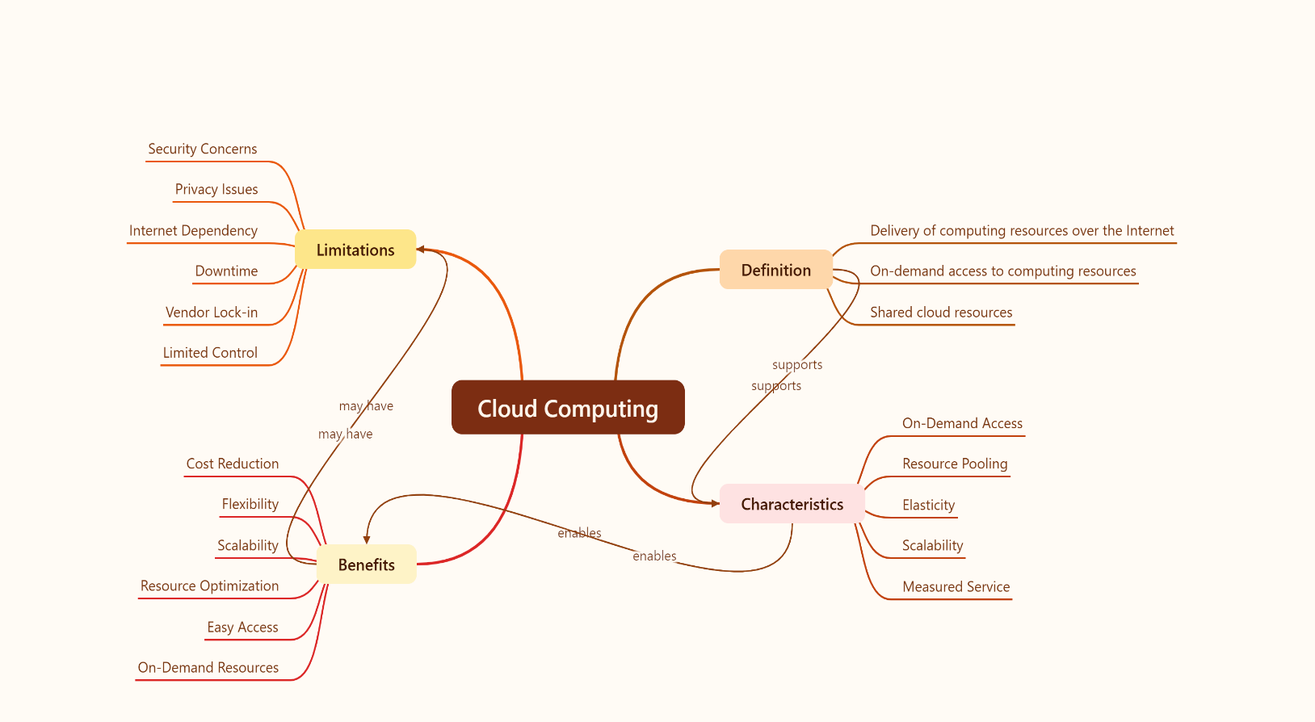
Concept Map 1: Cloud Computing Fundamentals. Include definition, characteristics, benefits, and limitations.

Concept Map 2: Evolution of Cloud Computing. Connect hardware evolution, internet software evolution,distributed systems, and service delivery.
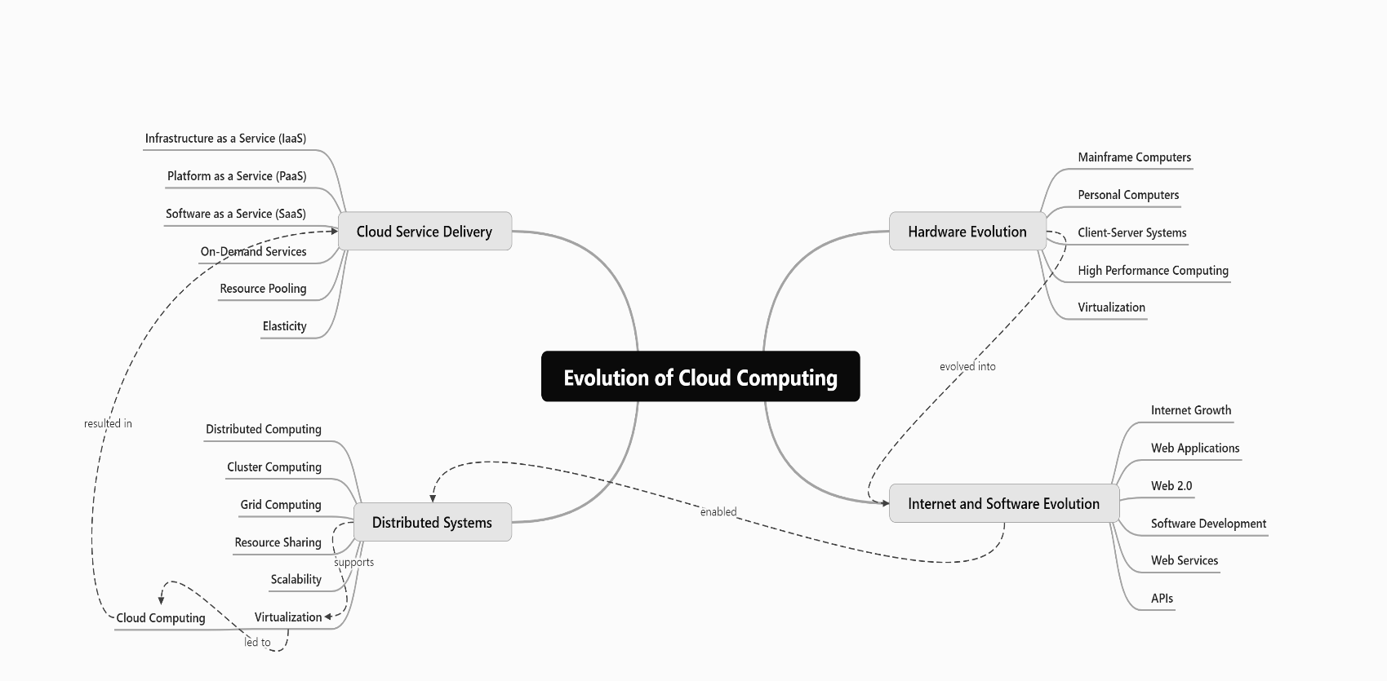

Concept Map 3: Service Models. Map IaaS, PaaS, SaaS, and XaaS with provider responsibilities and user responsibilities.

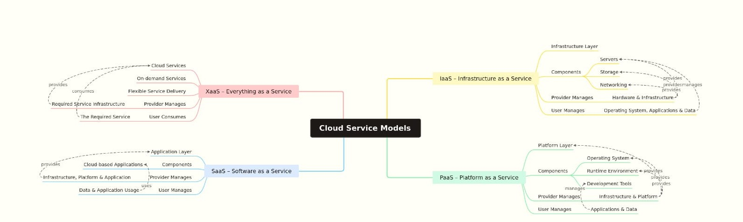

Concept Map 4: Virtualization and Web Services as Enablers of Cloud. Show how these two concepts support cloud deployment and scalability.
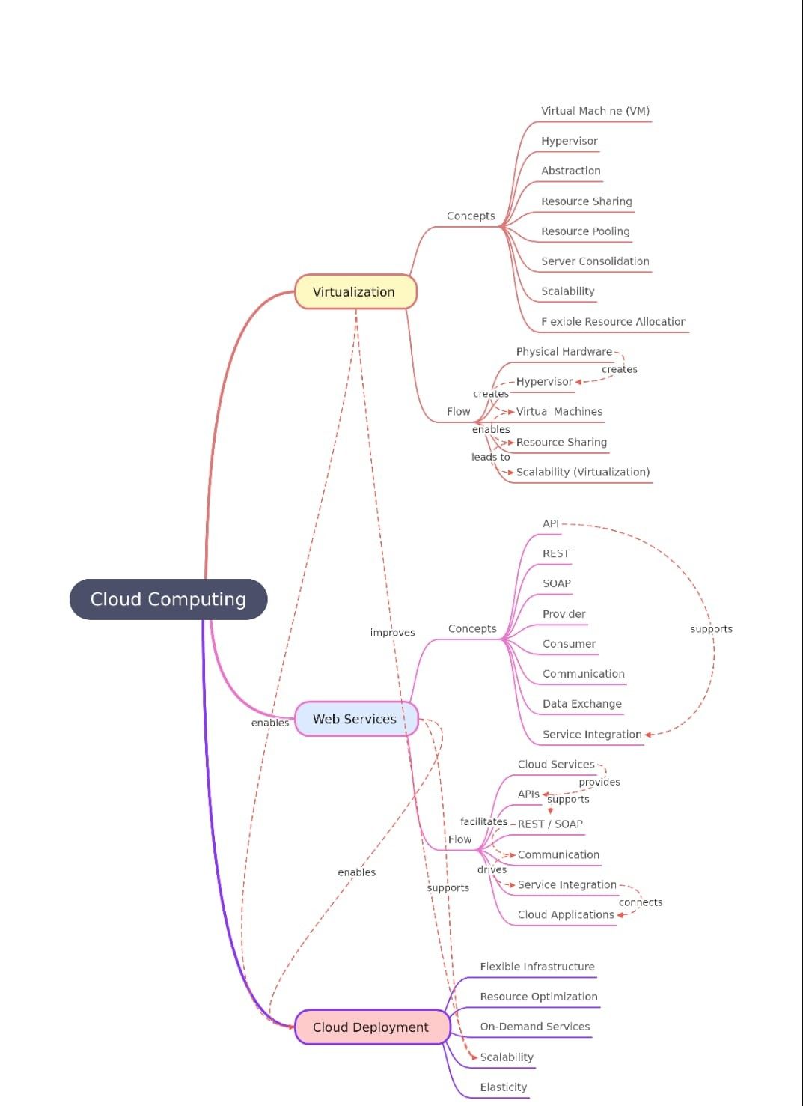

1. Evaluate the effectiveness of your concept map in representing cloud computing principles. Which
design decisions most strongly support your solution, and why?

Answer:

The concept map is effective because it presents the important cloud computing concepts in a clear and organized manner. It shows the relationships between cloud fundamentals, service models, virtualization, web services, scalability, and elasticity. The use of a proper hierarchy and labeled connections makes the concepts easier to understand.
The strongest design decisions are the clear grouping of related concepts, meaningful arrows, and simple visual structure. These decisions help show how virtualization supports cloud deployment, how web services enable communication, and how scalability and elasticity support efficient cloud computing. Therefore, the concept map provides a clear representation of the major cloud computing principles.

2.Analyze how scalability, elasticity, and resource management influence the architecture shown in your
concept map. What challenges could arise if these capabilities were absent?

Answer:

Scalability, elasticity, and resource management are important parts of my cloud architecture. Scalability helps the system handle more users and workloads when demand increases. Elasticity allows resources to be increased or reduced based on the current requirement. Resource management helps use computing resources properly and avoid unnecessary usage.
If these capabilities were absent, the system could become slow when many users access it at the same time. It may also waste resources when the workload is low and could lead to higher costs. Overall, these capabilities help the cloud system remain flexible and efficient.

3.Justify the selection of the APIs, web services, or cloud services included in your concept map. How do they contribute to the overall functionality and efficiency of the system?

Answer:

I selected APIs, REST, and SOAP web services because they help different applications and cloud services communicate with each other. APIs provide a way to access cloud services, while REST and SOAP support data exchange between the provider and consumer. These services make the system easier to connect, manage, and use.
They also improve the functionality and efficiency of the system by allowing different services to work together without directly depending on each other. Overall, APIs and web services make cloud applications more flexible and easier to integrate.

4. Critically examine the relationships between the components in your concept map. How do these interactions improve reliability, performance, or user experience?

Answer:

The components in my concept map are connected in a logical way. Virtualization helps manage resources efficiently, while APIs and web services allow different cloud services and applications to communicate with each other. Scalability and elasticity help the system handle changes in workload and user demand.
These interactions improve reliability and performance by allowing resources and services to work together efficiently. They also improve the user experience because users can access cloud services smoothly and get the required resources when needed. Overall, the relationships between the components make the cloud system more flexible and efficient.

5. Reflect on the process of developing your concept map. How has creating and analyzing the map changed your understanding of cloud computing architecture, and what improvements would you make if you were redesigning it?

Answer:

While developing my concept map, I understood how the different parts of cloud computing architecture are connected. Earlier, I understood concepts like service models, virtualization, APIs, scalability, and elasticity separately. Creating the map helped me understand how they work together in a cloud environment.
If I redesign the concept map, I would make the relationships between the components even clearer, improve the layout, and add a few more relevant examples. I would also make sure that the map is less crowded and easier to understand. Overall, creating the concept map improved my understanding of cloud computing architecture.

